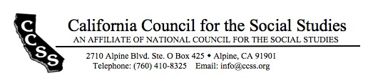

Board of Directors’ Motion Form

Date of Board Meeting: 8/27/17 Motion #: 2017Aug-7

Top of Form
Moved by: Pamela Harter Seconded by: Michelle Herczog
Bottom of Form

Dear Board of Directors, please find this motion for approval.
WHEREAS…
There are 11 Framework rollout events and two conferences in California within the next school year; and,
CCSS has an ongoing push to capture new members and a potentially receptive audience at these events;

BE IT RESOLVED THAT…
The Membership Committee will use its budget to print and ship 2500 bookmarks, to be used at framework rollouts, conferences, and other history social studies events throughout the state.

Top of Form
Outcome of the motion amendment: x passed failed tabled
Bottom of Form

ACTIONS REQUIRED:

1. Drafting of bookmark
By: Full committee
Date of completion: 8/27
2. Order placed following draft
By: Whitney Olson/Membership
Date of completion: ???

3. Shipped to Michelle Herzog to disperse at Framework, and bring extra to NCSS (Pamela to take over)
By: Pamela Harter
Date of Completion: ???

