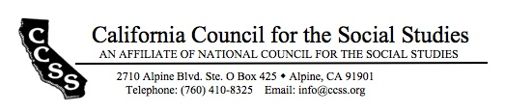

Board of Directors’ Motion Form

Date of Board Meeting: 8/27/17 Motion #: 2017Aug-6

Top of Form
Moved by: Michelle Herczog Seconded by: Greg Spielman
Bottom of Form

Dear Board of Directors, please find this motion for approval.
WHEREAS…
The CCSS Legislative Analyst is responsible for
- fulfilling the goal of CCSS to advocate for high quality social studies policy and practice; and

WHEREAS…
- The CCSS travel budget allocation for the Legislative Analyst to travel to CCSS official meetings and events to share his expertise is insufficient to fully support his work;

BE IT RESOLVED THAT…
The CCSS budget for travel expenses for the Legislative Analyst be raised from $1,500 to $2,500 to strengthen collaboration with partner organizations, provide more access to membership, speak at public forums, and participate more fully in CCSS meetings and events.

The $1,000 increase will come from the surplus.

Top of Form
Outcome of the motion amendment: X passed failed tabled
Bottom of Form

ACTION REQUIRED: Modify budget; post new budget on website and elsewhere.

1. By: Avi
Date of completion: September 15, 2017

