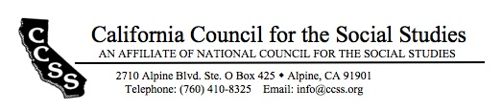

Board of Directors’ Motion Form

Date of Board Meeting: 8/27/17 Motion #: 2017Aug-5

Top of Form
Moved by: Cricket Kidwell Seconded by: Mary Janzen
Bottom of Form

Dear Board of Directors, please find this motion for approval.
WHEREAS…
The Government Relations Committee is dedicated to:
- Fulfilling the goal of CCSS to advocate for high quality social studies policy and practice;
- Breaking down walls; and
- Building connections, collaboration and civil discourse;

BE IT RESOLVED THAT…
The Government Relations Committee will spend up to the $300 allocated in their committee budget to purchase high quality mementos and keepsakes to promote the work of the committee, to be distributed to attendees at the 2018 Legislative Breakfast and Confab Meeting.

Top of Form
Outcome of the motion amendment: X passed failed tabled
Bottom of Form

ACTION REQUIRED: NOT IDENTIFIED

1. By: Gov Relations Committee
Date of completion: March 2018
2. By:
Date of completion:

3. By:
Date of Completion:

