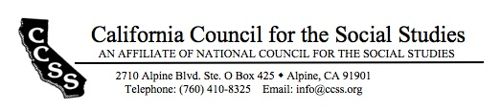

Board of Directors’ Motion Form

Date of Board Meeting: 8/27/17 Motion #: 2017Aug-1

Top of Form
Moved by: Michelle Herczog Seconded by: Katherine Rand
Bottom of Form

Dear Board of Directors, please find this motion for approval.
WHEREAS…

Restaurant costs have risen since the last meal reimbursement schedule was approved;

BE IT RESOLVED THAT…

The per diem reimbursement schedule for meals shall be increased to the following maximum figures:
- Breakfast: $10
- Lunch: $15
- Dinner: $25

Top of Form
Outcome of the motion amendment: X passed failed tabled
Bottom of Form

ACTIONS REQUIRED:

Reimbursement form to reflect new figures, as above.

By: Avi Black
Date of completion: September 15

