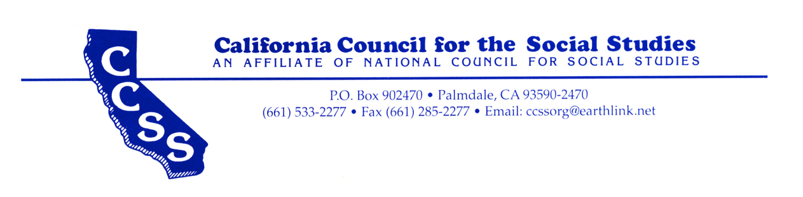

P.O. Box 1187, Weimar, CA 95736

Telephone: (530) 305-7290 Email: info@ccss.org