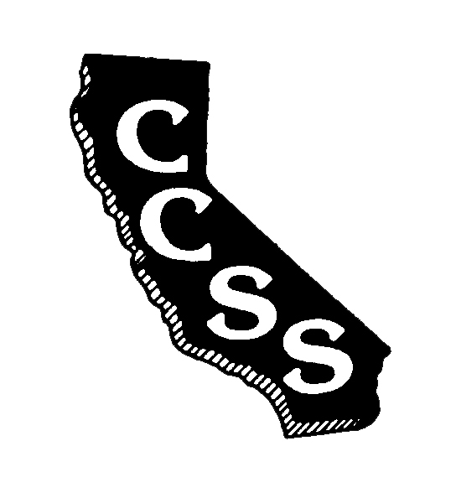
California Council for the Social Studies

A AN AFFILIATE OF NATIONAL COUNCIL FOR THE SOCIAL STUDIES

P P.O. Box 2075 * Berkeley, CA 94702 * PH: 510-301-7628 * info@ccss.org

Board of Directors Meeting
Agenda
Saturday, May 19, 2018
10:00 AM-4:00 PM
Hoover Middle School
1635 Park Avenue, San Jose, CA 95126

Improve Efficiency * Strengthen Partnerships * Expand Social Media Presence

President’s Welcome N. Wojinski

Strategic Planning Activities Info/Discussion U. Holland/EC

Lunch

Consent Items
- March Meeting Minutes Approval Action A. Black

Ongoing Business
- Executive Director’s Report Info A. Black
  - Membership
  - Financial
  - SSR
  - Local Council Allocations
- Liaison Reports Info J. Mann
C. Crawford
- Legislative Report Info F. Jones
- Committee Reports Info Committee Chairs
- Conference 2019 Report Info D. Connet,
A. Black
- Partnerships Update Info M. Herczog
- Motion to Approve ED Compensation Action A. Black

New Business
- Motion to Ratify Election Results Action Board of Tellers
- Populating Operational Committees Action N. Wojinski
- Motion to Approve Interim (July/Aug) Budget Action A. Black
- Motion to Approve Contracts Action A. Black
- Motion to Approve ED Contract Extension Action A. Black
- Conference 2020 Update Info M. Herczog
- Motion to Approve Conference 2021 Site Action A. Black
- Creation of “Partnerships” Task Force Discussion/Action N. Wojinski

Oral Communications – Members are welcome to share information

Adjournment

Partnering Organizations/Liaisons
ABOTA Foundation
CA Council on Economic Education
CA Department of Education
CA Geographic Alliance
CA History- Social Science Project
CA International Studies Project
CA Teachers Association
Center for Civic Education
Civic Mission of Schools
Constitutional Rights Foundation
Council for History Education
Facing History and Ourselves
National Council for the Social Studies
Ronald Reagan Presidential Foundation and Institute
Others in development

Sponsoring Organizations
Big History Project
DBQ Project
Discovery Learning
Heifer International
Indiana University Center on Representative Government
McGraw-Hill Education
National Geographic-Cengage
Pearson Education
Perfection Learning
Social Studies Schools Service
Studies Weekly
Teachers’ Curriculum Institute

