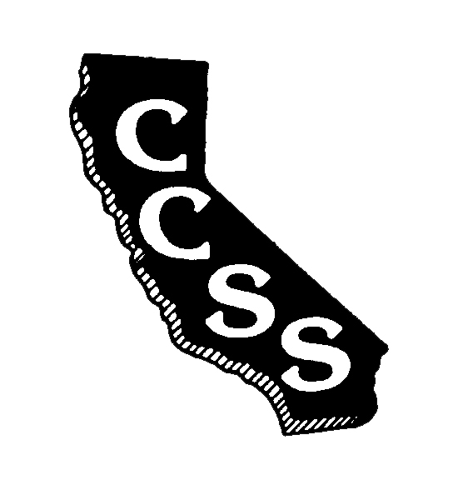
California Council for the Social Studies

A AN AFFILIATE OF NATIONAL COUNCIL FOR THE SOCIAL STUDIES

P P.O. Box 2075 * Berkeley, CA 94702 * PH: 510-301-7628 * info@ccss.org

Board of Directors Meeting
Agenda
Sunday, August 27, 2017
Town and Country Resort and Convention Center
500 Hotel Circle North, San Diego, CA 92108
8:00 am – 2:00 pm

Improve Efficiency * Strengthen Partnerships * Expand Social Media Presence

Welcome/Goals-Vision-Mission-Values Info (15’) Wojinski

Executive Director’s Report Info (20’) A. Black
- Budget – Membership

Area-Based Conferrals (cont’d from Saturday) Discussion (20’) Area VP’s

Consent Items
- May Meeting Minutes Action (5’) A. Black

Ongoing Business
- Reimbursement policy Info (15’) A. Black
- Regional (re-)affiliation policy Info (15’) A. Black

Break (15’)

Old Business – Task Forces
- ED/ES Search Info/Action (60’) Herczog
- Strategic Planning Info/Action (45’) D. Black

Lunch (45’)

New Business – Operational Committees
- Governmental Relations Info/Action (15’) Kidwell
- Publications & Technology Info/Action (15’) Day

New Business – Standing Committees
- Membership & Outreach Info/Action (15’) Harter/Abercrombie
- Curriculum & Instruction Info/Action (15’) Valbuena
- Diversity & Social Justice Info/Action (15’) Luevanos
- Professional Standards & Awards Info/Action (15’) Rehome

Partnering Organization/Liaison Reports
ABOTA Foundation
CA Council for Economic Education
CA Department of Education
CA Geographic Alliance
CA History- Social Science Project
CA International Studies Project
CA Teachers Association (nfo (5’) Crawford
Center for Civic Education
Civic Mission of Schools
Constitutional Rights Foundation
Council for History Education
Facing History and Ourselves
National Council for the Social Studies
Ronald Reagan Foundation
Others in development

Oral Communications – Members are welcome to share information (10’)

Adjournment at 2:00 PM

Conference Committee Meeting – Begins at 2:15 PM

