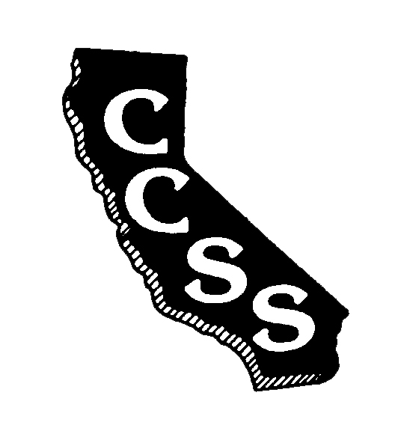
California Council for the Social Studies

A AN AFFILIATE OF NATIONAL COUNCIL FOR THE SOCIAL STUDIES

P P.O. Box 2075 * Berkeley, CA 94702 * PH: 510-301-7628 * info@ccss.org

P
Annual Committees Meeting
Agenda
Saturday, August 26, 2017
Town and Country Resort and Convention Center
500 Hotel Circle North, San Diego, CA 92108
10:30 am – 4:30 pm

Improve Efficiency * Strengthen Partnerships * Expand Social Media Presence

Welcome: Purpose of Our Work/ N. Wojinski 10:30 – 10:45
Priorities for the Year

Introductions to… 10:45 – Noon
- Organizational structure, goals A. Black
and responsibilities
- Wild Apricot platform/database A. Black
- Google Docs N. Wojinski
- Area priorities Area V.P.’s

Conference 2018 Report G. Spielman Noon – 12:15

Legislative Update F. Jones 12:15 – 12:30

Lunch 12:30 – 1:00

Social Media Activity S. Petri 1:00-1:15

Committee Meetings Committee Chairs 1:15 – 4:00
  - Membership & Outreach P. Harter/B. Abercrombie
  - Diversity & Social Justice R. Luevanos
  - Governmental Relations C. Kidwell
  - Professional Standards & Awards C Rehome
  - Publications & Awards B. Day
  - Curriculum & Instruction R. Valbuena
  - Local Councils (start 2:00) A. Black

Debrief and Closure M. Janzen 4:00 – 4:30

NOTE: All motions must be completed on official “Board Motion” forms (located at www.ccss.org on the “Board of Directors” page). Motions must be emailed to the Executive Director shortly after the close of the meeting to be considered for Board review on Sunday, August 27, 2017. Committee reports should also be submitted via email to info@ccss.org. Please enter your committee title in the subject line of your email. You may include your update in the body of the email or as an attachment in Word. All submitted reports will be added to the minutes and routed to members after the Board meeting.

