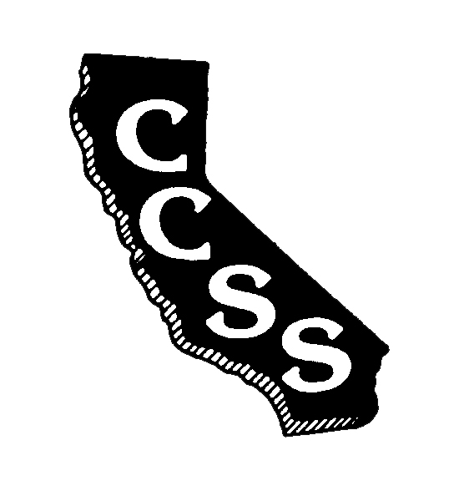
California Council for the Social Studies

A AN AFFILIATE OF NATIONAL COUNCIL FOR THE SOCIAL STUDIES

P P.O. Box 2075 * Berkeley, CA 94702 * PH: 510-301-7628 * info@ccss.org

P
Annual Committees Meeting
Agenda
Saturday, August 25, 2018
Herbert Hoover Middle School
1635 Park Avenue, San Jose, CA 95126
10:30 am – 4:30 pm

Community * Capacity * Strategic Planning

Welcome: Purpose of Our Work/ M. Janzen 10:30-10:45
Priorities for the Year

Introductions to… 10:45 – 11:00
- Wild Apricot platform/database /documents A. Black

Conference 2019 Report D. Connet 11:00-11:20 V. Doherty

Legislative Update F. Jones 11:20- 12:00
J. Mann

Lunch 12:00 – 12:30

Committee Meetings – Intro & Instructions M. Herczog 12:30 – 4:00
  - Conference Committee
  - Membership & Outreach
  - Diversity & Social Justice
  - Governmental Relations
  - Professional Standards & Awards
  - Publications & Awards
  - Curriculum & Instruction

Debrief and Closure M. Janzen 4:00 – 4:30

NOTE: All motions must be completed on official “Board Motion” forms (located at www.ccss.org on the “Board of Directors” page). Motions must be emailed to the Executive Director shortly after the close of the meeting to be considered for Board review on Sunday, August 26, 2018. Committee reports should also be submitted via email to info@ccss.org. Please enter your committee title in the subject line of your email. You may include your update in the body of the email or as an attachment in Word. All submitted reports will be added to the minutes and routed to members after the Board meeting.

