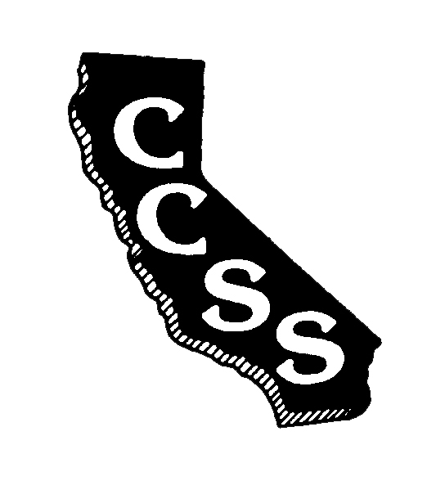
California Council for the Social Studies

A AN AFFILIATE OF NATIONAL COUNCIL FOR THE SOCIAL STUDIES

P P.O. Box 2075 * Berkeley, CA 94702 * PH: 510-301-7628 * info@ccss.org

Board of Directors Meeting
Agenda
Sunday, August 26, 2018
Herbert Hoover Middle School
1635 Park Ave, San Jose, CA 95126
8:00 am – 2:00 pm

Community * Capacity * Strategic Planning

Welcome/Goals-Vision-Mission-Values Info (5’) Janzen

Executive Director’s Report Info (15’) A. Black
- Membership
- Reimbursement Policy
- Regional (Re-)Affiliation Policy

Consent Items
- May Meeting Minutes Action (5’) A. Black

Introductory Activities Social (30’) Wojinski
Janzen

Old Business
- New ES: Role/Communication Info/Action (15’) Herczog

Ongoing Business – Task Forces/Reports
- Strategic Planning Info (20’) D. Black
- CTA Report Info (5’) Crawford

Break (15’)

New Business – Committees/Working Groups
- Staffing IPP’s Operational Committees Info (10’) Wojinkski
- Standing/Operational Committee Motions Info/Action (60’) Chairs
- Conference 2019 Info (15’) Connet
- Partnerships/Endorsements Working Group(s) Info/Action (15’) Janzen

Lunch (45’)

New Business
- Final 2018-2019 Budget Info/Action (60’) Janzen
- Conference Siting 2021 Info/Action (25’) A. Black
- Conference Siting 2022 Info/Action (5’) A. Black

Partnering Organization/Liaison Reports
ABOTA Foundation
CA Council for Economic Education
CA Department of Education
CA Geographic Alliance
CA History- Social Science Project
CA International Studies Project
CA Teachers Association
Center for Civic Education
Civic Mission of Schools
Constitutional Rights Foundation
Council for History Education
Facing History and Ourselves
National Council for the Social Studies
Ronald Reagan Foundation
Others in development

Oral Communications – Members are welcome to share information

Adjournment 2:00 pm

