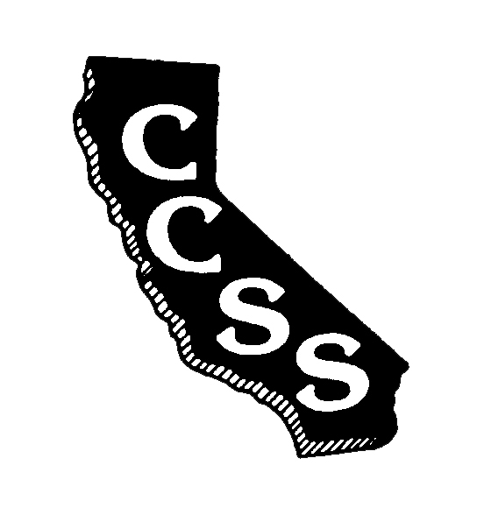
California Council for the Social Studies

A AN AFFILIATE OF NATIONAL COUNCIL FOR THE SOCIAL STUDIES

P P.O. Box 2075 * Berkeley, CA 94702 * PH: 510-301-7628 * info@ccss.org

Board of Directors Meeting
Agenda
Saturday, March 24, 2018
6:45-8:30 PM
Town and Country Resort and Convention Center – Tiki Pavilion
500 Hotel Circle North, San Diego, CA 92108

Improve Efficiency * Strengthen Partnerships * Expand Social Media Presence

President’s Welcome Info N. Wojinski

Activity with Partnering Organizations: Discussion A. Black
How Can CCSS Best Serve the Social Studies
Teaching Community?

What Does It Mean to be a NCSS Affiliate Council? Info L. Paska

Consent Items
- January Meeting Minutes Approval Action A. Black

Ongoing Business
- Executive Director’s Report Info A. Black
  - Membership
  - Financial
- Conference 2018 Report Info G. Spielman
- Committee Reports Info Committee Chairs

New Business
- Presentation/Approval of Slate of Action/Info D. Connet
Candidates for CCSS Board
  - Report on election timeline N. Wojinski/
M. Janzen

Oral Communications – Members are welcome to share information

Adjournment

Partnering Organizations/Liaisons
ABOTA Foundation
CA Council on Economic Education
CA Department of Education
CA Geographic Alliance
CA History- Social Science Project
CA International Studies Project
CA Teachers Association
Center for Civic Education
Civic Mission of Schools
Constitutional Rights Foundation
Council for History Education
Facing History and Ourselves
National Council for the Social Studies
Ronald Reagan Presidential Foundation and Institute
Others in development

Sponsoring Organizations
Big History Project
DBQ Project
Discovery Learning
Heifer International
Indiana University Center on Representative Government
McGraw-Hill Education
National Geographic-Cengage
Pearson Education
Perfection Learning
Social Studies Schools Service
Studies Weekly
Teachers’ Curriculum Institute

