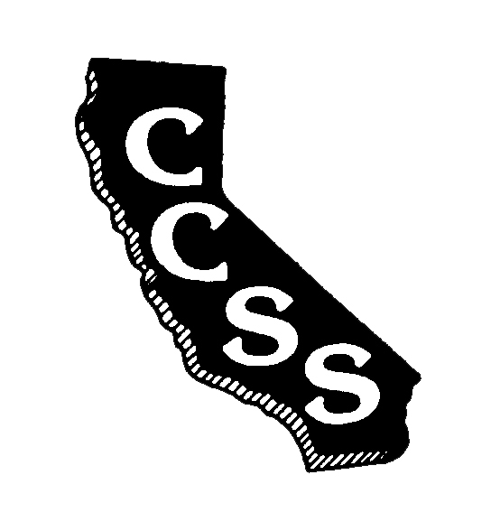
California Council for the Social Studies

A AN AFFILIATE OF NATIONAL COUNCIL FOR THE SOCIAL STUDIES

P P.O. Box 2075 * Berkeley, CA 94702 * PH: 510-301-7628 * info@ccss.org

Board of Directors Meeting
Agenda
Saturday, January 27, 2018
Santa Clara County Office of Education
1290 Ridder Park Drive, San Jose, CA 95131
10:00 am – 4:00 pm

Improve Efficiency * Strengthen Partnerships * Expand Social Media Presence

Welcome/Goals-Vision-Mission-Values Info (5’) Wojinski

Executive Director’s Report/Q&A Info (40’) A. Black
- Meeting purpose and goals
- Financial report
- Membership update
- EC accomplishments

Consent Items
- August Meeting Minutes Action (5’) Wickham

Ongoing Business
- Conference 2018 Update Info (35’) Spielman/A. Black
- Conference 2019 Update Info (5’) Connet

Break (15’)

Partnering Organization/Liaison Reports Info (15’) Crawford

Legislative Report/Questions Info (30’) Jones

Old Business – Task Forces/Committees
- Publications/SSR Info (5’) Rocca
- Strategic Planning Info (5’) D. Black/Vicario

Lunch (30’)

New Business
- ED/Office Manager Positions/Contracts Info/Action (30’) A. Black
- Social Media Working Group Info (10’) Petri

Hands-On Wild Apricot Tutorial Info/Working (40’) Committee Chairs

Working Time – Standing/Operational Committees Working (90’) Committee Chairs

Oral Communications – Members are welcome to share information

Adjournment

Partnering Organizations/Liaisons
ABOTA Foundation
CA Council on Economic Education
CA Department of Education
CA Geographic Alliance
CA History- Social Science Project
CA International Studies Project
CA Teachers Association
Center for Civic Education
Civic Mission of Schools
Constitutional Rights Foundation
Council for History Education
Facing History and Ourselves
National Council for the Social Studies
Ronald Reagan Presidential Foundation and Institute
Others in development

Sponsoring Organizations
Big History Project
DBQ Project
Discovery Learning
McGraw-Hill Education
National Geographic-Cengage
Pearson Education
Perfection Learning
Social Studies Schools Service
Studies Weekly
Teachers’ Curriculum Institute

